Ideation Phase
Empathize & Discover
Date | 05 October 2026
Team ID | SWTID-2026-4458
Project Name | Import Data using Transform Maps (Spreadsheet)
Team Leader | Monika B
Team Members | D Keerthana, Chandhana S, Vemalaraju Poojitha, Subasri R
Maximum Marks | 4 Marks
Empathy Map Canvas:
An empathy map is a simple, easy-to-digest visual that captures knowledge about a user’s behaviours and attitudes.
It is a useful tool to helps teams better understand their users. Creating an effective solution requires understanding the true problem and the person who is experiencing it. The exercise of creating the map helps participants consider things from the user’s perspective along with his or her goals and challenges.
Example:
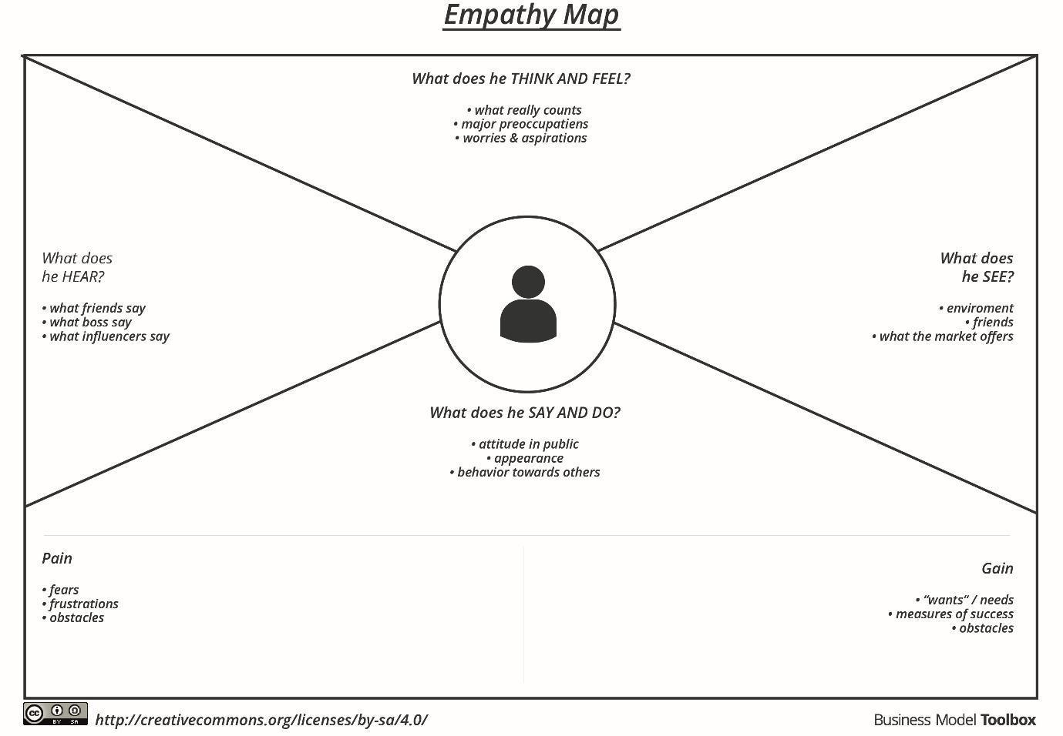
Reference: https://www.mural.co/templates/empathy-map-canvas

Example: Food Ordering & Delivery Application
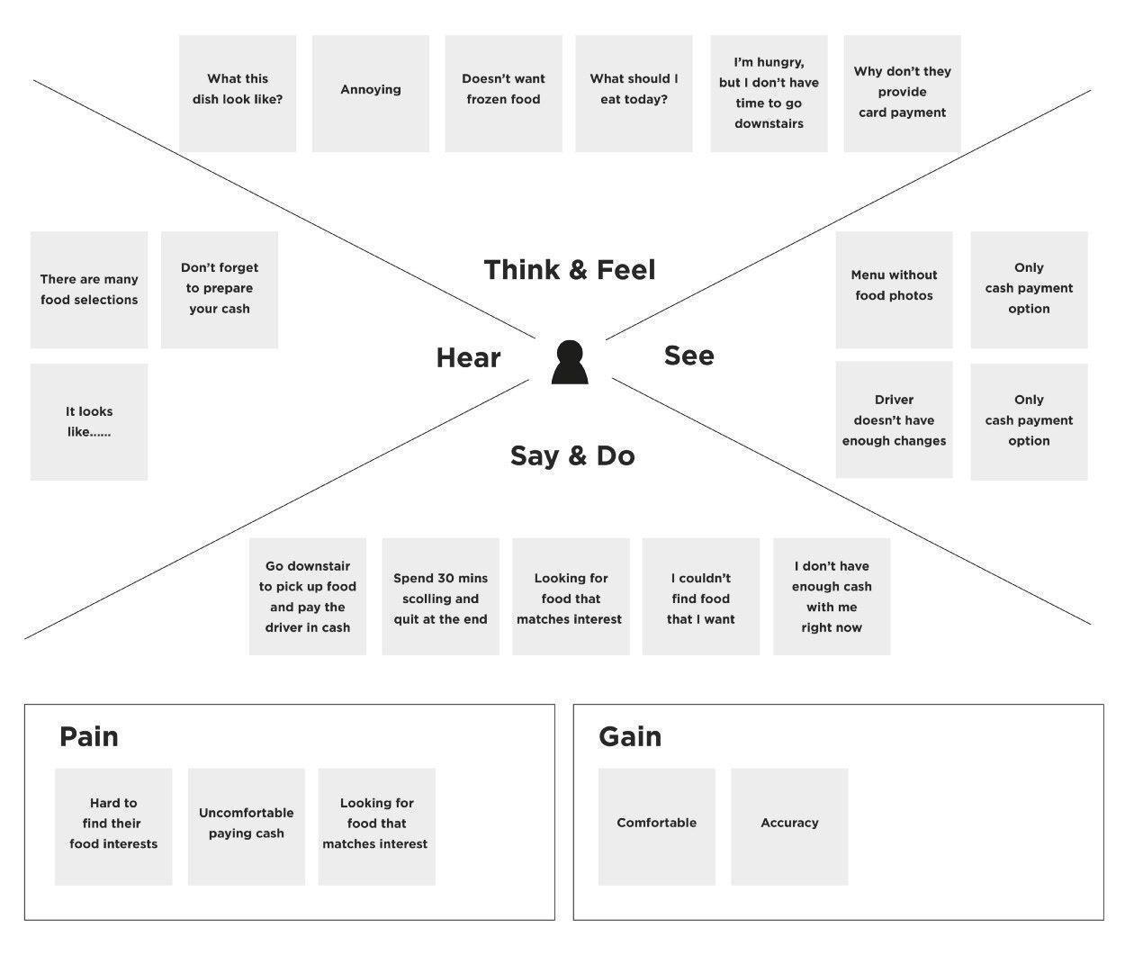
Our Empathy Map: Employee Data Import User
User in focus: a ServiceNow Administrator who receives employee data in Excel format and imports it into the Employee table, supported by the Data Owner who needs the records to be accurate.
SAYS | THINKS
"Why were some employees added twice?"  "Did the spreadsheet update the existing records or create new ones?"  "Can the system match employees by Employee ID automatically?" | "If I import now, will it overwrite the wrong records?"  "Are all the columns mapped to the right fields?"  "I hope there are no blank or duplicate Employee IDs in the file."
DOES | FEELS
Receives employee data in Excel format and prepares it for upload  Loads the spreadsheet into the Import Set table  Maps each source field to the Employee table field in the Transform Map  Runs the transform and checks the records afterwards | Frustrated by manual entry and repeated corrections  Anxious about duplicate or incorrect employee data  Confused when fields are not mapped correctly  Relieved and confident when the import runs cleanly

PAINS | GAINS
Entering employee records one by one is slow and error-prone  Duplicate employees are created when records are not matched  No staging area to check data before it reaches the live table  Hard to confirm what was inserted, updated or ignored | Bulk import of employee data in one step  Employee ID coalesce updates existing records and inserts only new ones  Import Set table gives a safe staging area for validation  Transform history makes results easy to verify  Accurate data for reports and the employee dashboard

